**Connect to the Store Sales Data and do the following: -**

**− Remove all the blank rows.**

**− Update the column header if they are not updated**

**− Create a text table and show the sales Customers, Product, Category, in terms of Regions**

**Remove all the blank rows.**

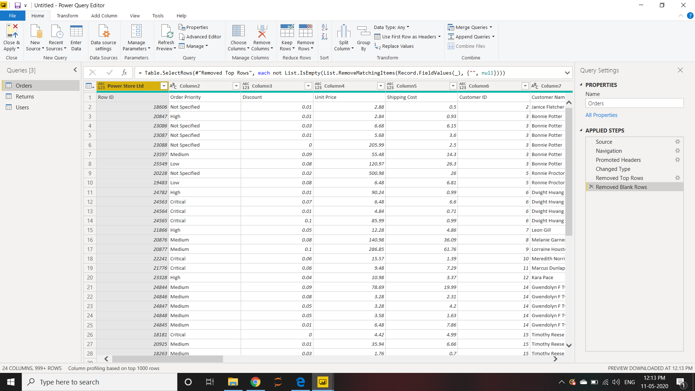

**Update the column header if they are not updated**

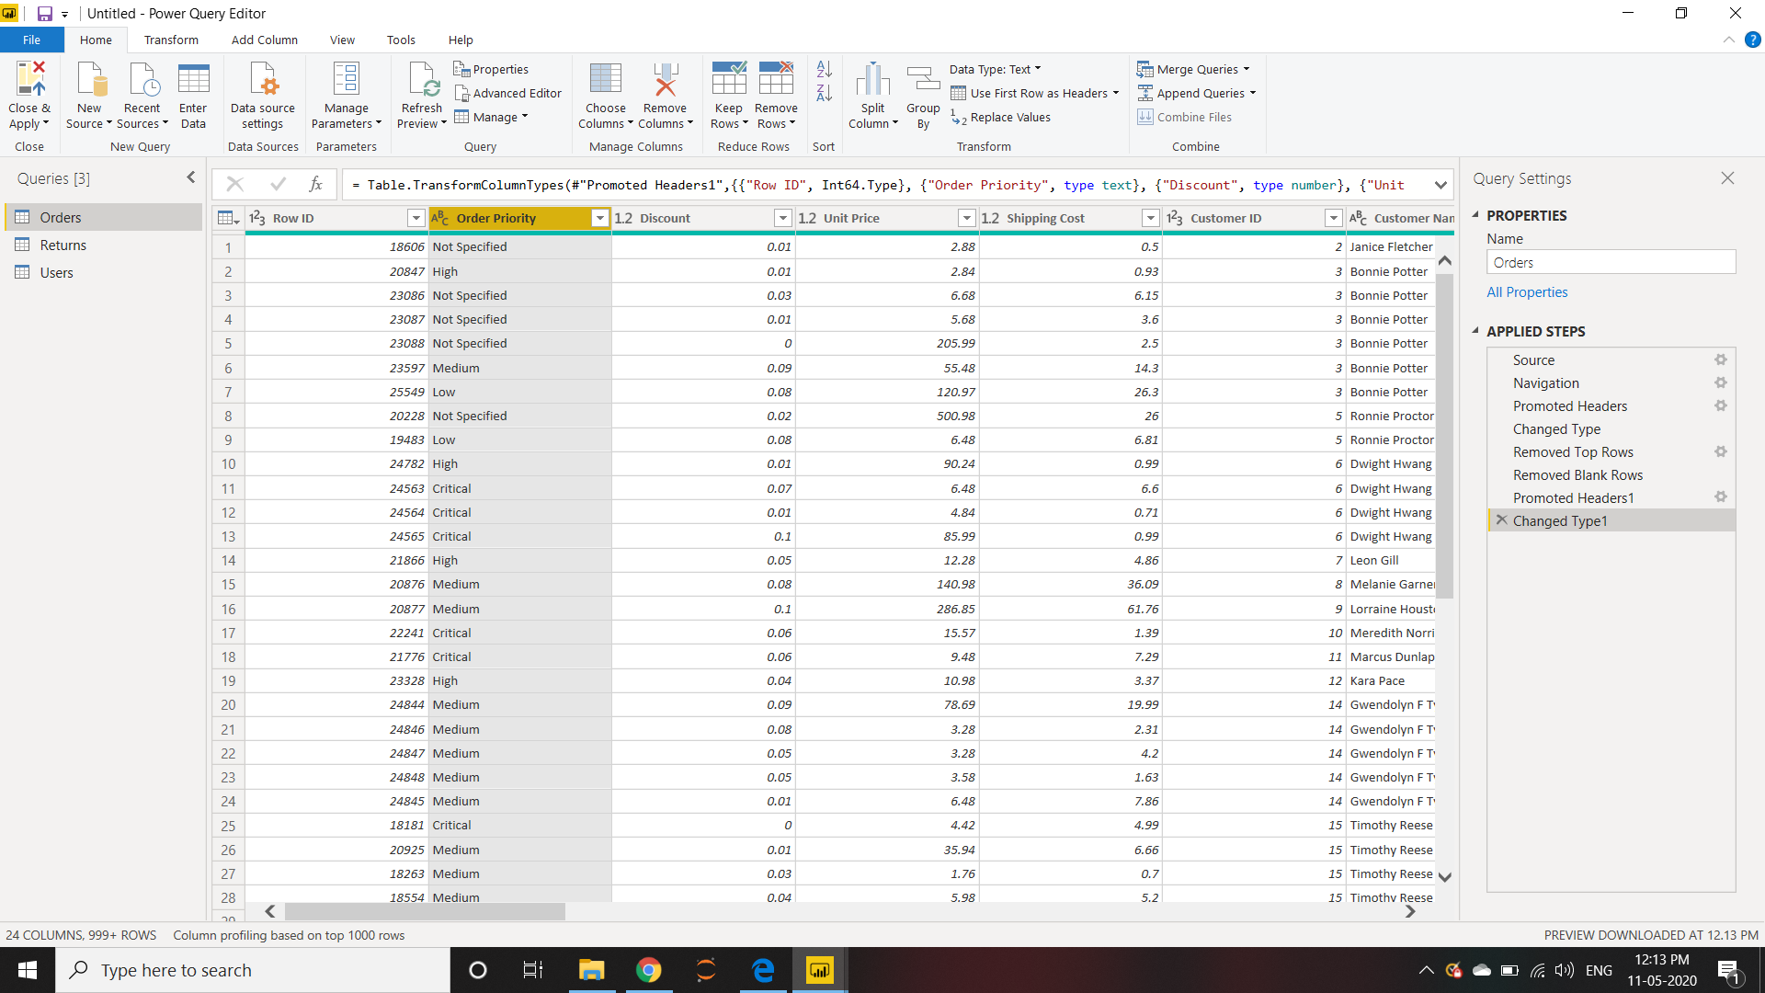

**Create a text table and show the sales Customers, Product, Category, in terms of Regions**

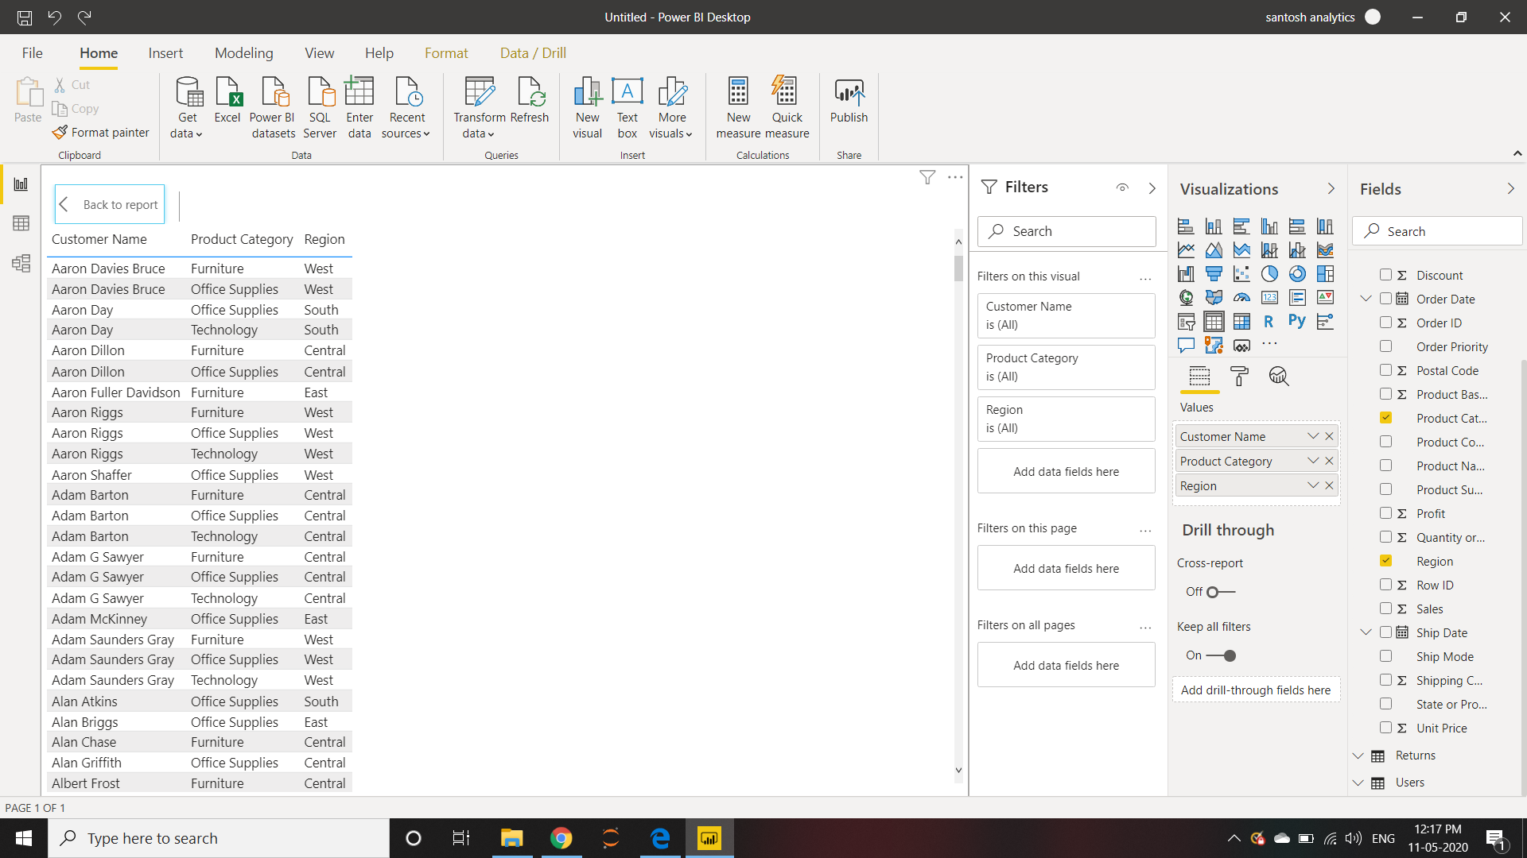

**Create a line and Clustered Column Chart showing the Sales and Discount as per the State or Province:**

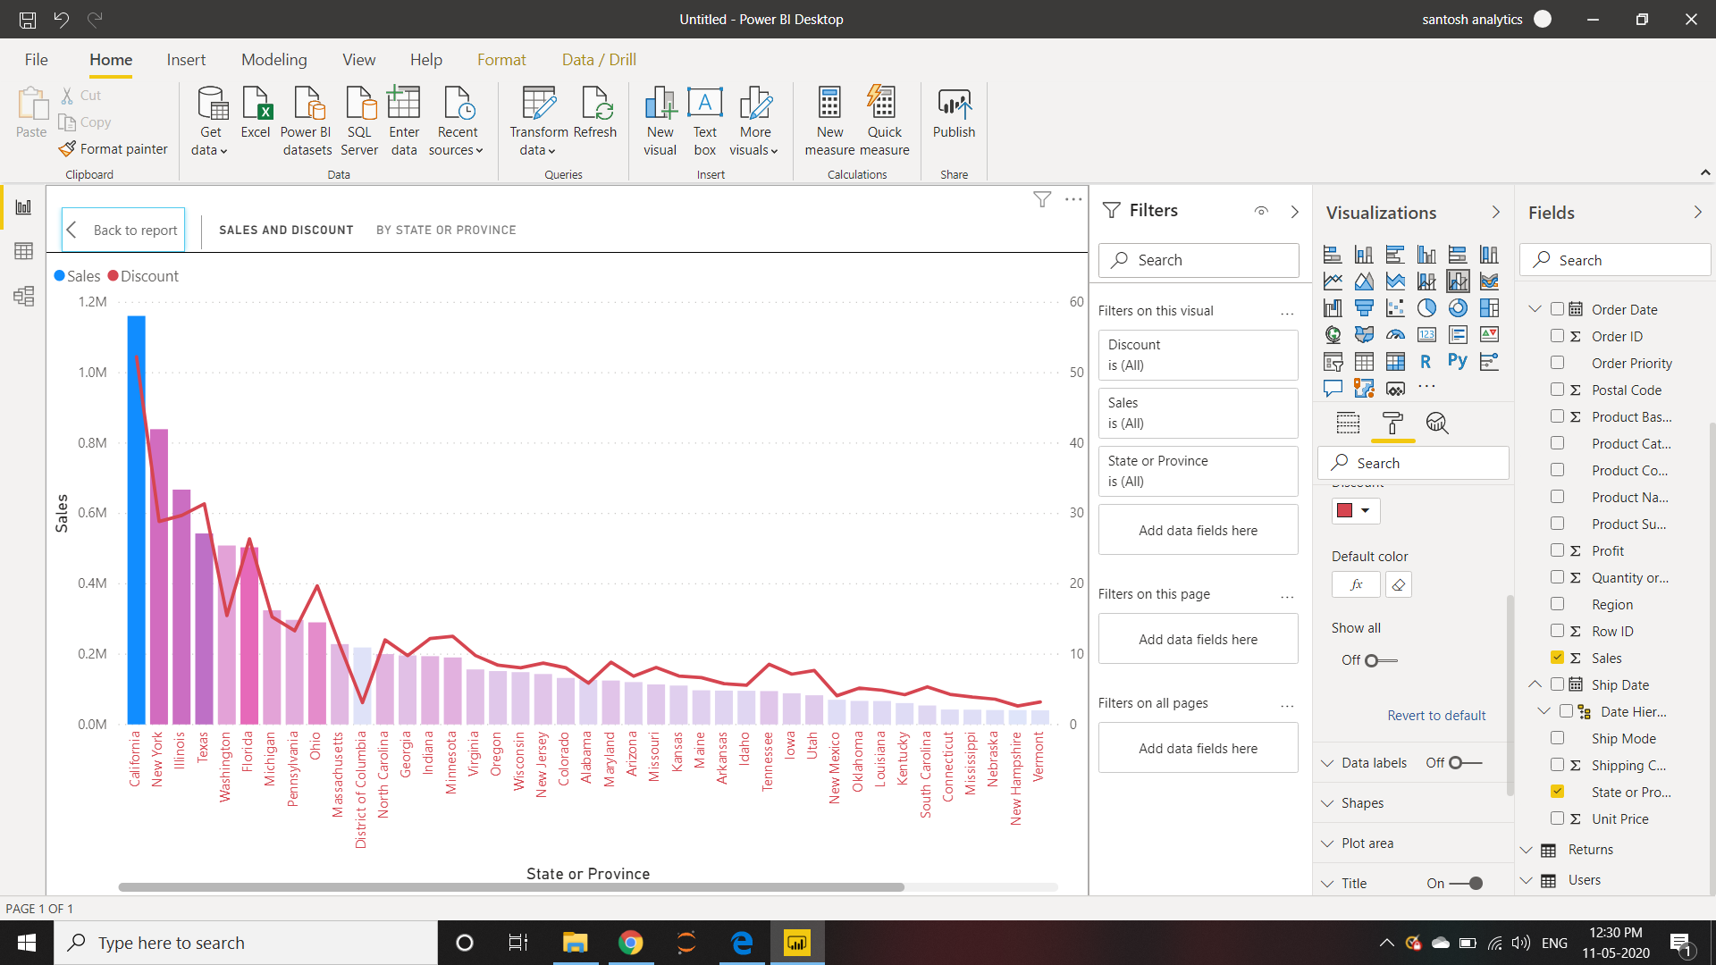

**Create a Donut Chart showing sales in terms of Product category:**

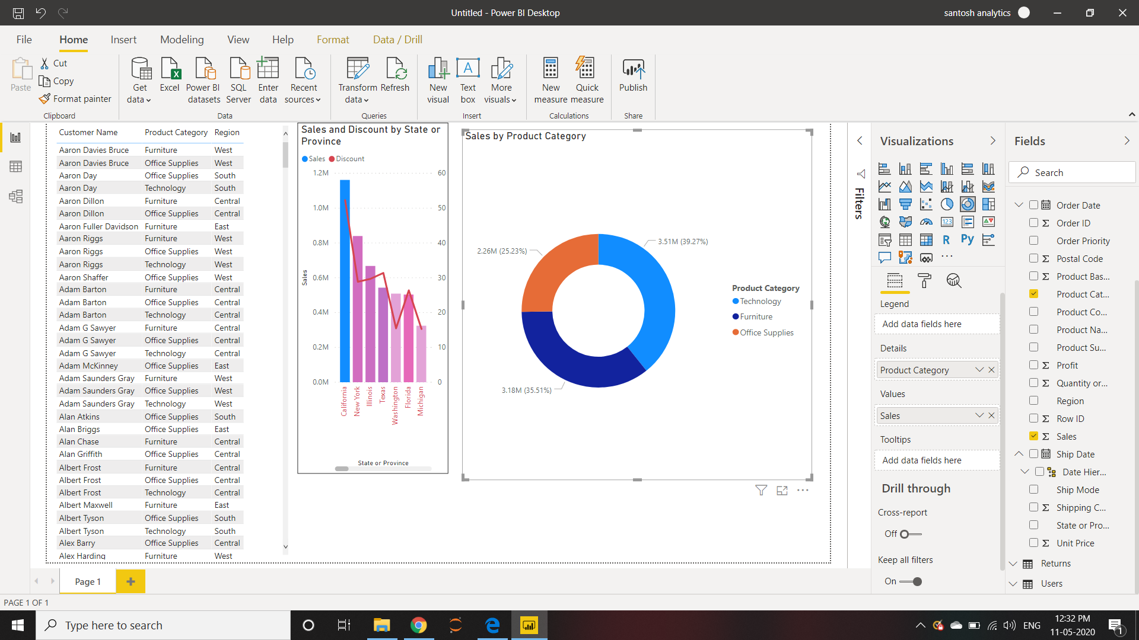

**Create a Slicer and show the regions in dropdown. See how all the visuals mentioned above behaving when a particular region is selected:**

